The conception of parameters and constraint-based models in
architectural projects: The case of Lele's pivot domes

Abstract

Following increasing interest among architects in the application of generative algorithms in the conception of projects, many questions have been raised concerning teaching this particular manner of thinking about forms. One of the main goals of learning the subject is to understand how the idea of the geometrical construction of a building element can be translated into the rules of an algorithm. Other aims are to introduce the requisite programming-related concepts to implement the algorithms, and to locate this method within the scope of disciplines involved in the construction activity. This paper proposes an example-based strategy to discuss these three crucial issues by using the pivot domes designed by Brazilian architect Lelé as the object of study.

Keywords: Parametric Models, Geometric Constraints, Generative Algorithms, Lelé

Introduction

The concepts, techniques, and applications of generative algorithms have offered significant gains in the last few decades, and have thus garnered considerable interest from architects, researchers, and teachers. Many leading global bureaus in the field of architecture have invested in implementing and maintaining programming departments to collaborate in the creative process of building design (CECCATO, 2010). The range of influence of computer-aided design (CAD) extrapolates the aspect of an applied tool and reaches aesthetic theories (OXMAN, 2006; PICON, 2011) and, through integration with computer-aided manufacturing (CAM) systems, construction activities (KOLAREVIC, 2003). Generative algorithms have contributed to this process.

In the academic world, the assimilation of the methods, tools, and knowledge involved in the understanding of generative design paradigms presents a range of possibilities and opportunities to rethink relations among disciplines involved in the design activities (BENTSCHEFF; GENGNAGEL, 2010; KOLAREVIC, 2003).

One of the main issues in teaching generative design to novice users is to make them understand how an initial idea can be translated into rules that generate forms. Understanding how these forms can be generated is the first step in this different approach to project activities encouraged by such algorithms. It is important to remember that this generation of forms in not an objective in itself, but merely a tool to assist in answering questions raised by architecture as an interdisciplinary domain. In that sense, the building of effective generative algorithms also relies on understanding the characteristics of the building or construction element that may need to be explored and tested by the process, and the manner in which different parameters act together in a way that the variety of forms created by them establish a set of possible solutions, each one with particular characteristics, to be disposed of or adopted by the user.

This paper proposes, as it’s main goal, an example-based strategy to introduce generative algorithms to students through the definition of the rules that governs a conceptual parametric model of an architectural element based on parameters and constraints. It´s safe to say that this goal couldn’t be achieved focusing only the programming/algorithmic aspects of the problem. The traditional methods for constructing the geometrical model is a fundamental part of the proposed teaching strategy. The knowledge of traditional geometry and it´s methods is fundamental and understanding how some of those methods where adapted to the computational environment represents an advantage to the student, as a connection between the traditional and the algorithmic modeling. While defining and manipulating the parameters is important to evaluate what performances or characteristics may be optimized or adjusted. Quantitative performances, such as natural light usage and air circulation in the present example, and qualitative characteristics (aesthetic) that could be modified by the manipulation of the parameters should be noticed. In addition to that, a brief historical overview of Lelé’s prolific works is presented.

Although aimed at architecture and construction, the contents explored in this article can be easily adopted by other fields, such as mechanical engineering, robotics, product design, among others. Whenever a demand exists for the conception of a form to be built, and the variations of this form could generate gains or losses in some performances or characteristics of the final product, the parametric design strategies could collaborate in obtaining better results meeting the same deadline.

Generative design and generative algorithms

Algorithms are defined as a finite set of rules that describe steps to solve a specific problem (KNUTH, 1997). The technical drawings applied in the design of architectural plans are, indeed, algorithms (TERZIDIS, 2006, Chap. 3). The sequential operations with compass, rule, and straight edges that are used to make a specific geometrical construction are finite and describes a well defined set of rules. Words such as "perpendicular," "parallel," and "tangent" summarize entire algorithms in the drafter's vocabulary. The development of CAD technology, began by providing the ability to reproduce drawing algorithms through software, and have since evolved to a "wider graphic vocabulary available to designers, together with a more elaborate syntax -- in all, a richer and potentially more expressive graphic and spatial language" (MITCHELL, 2008, Chap. 15).

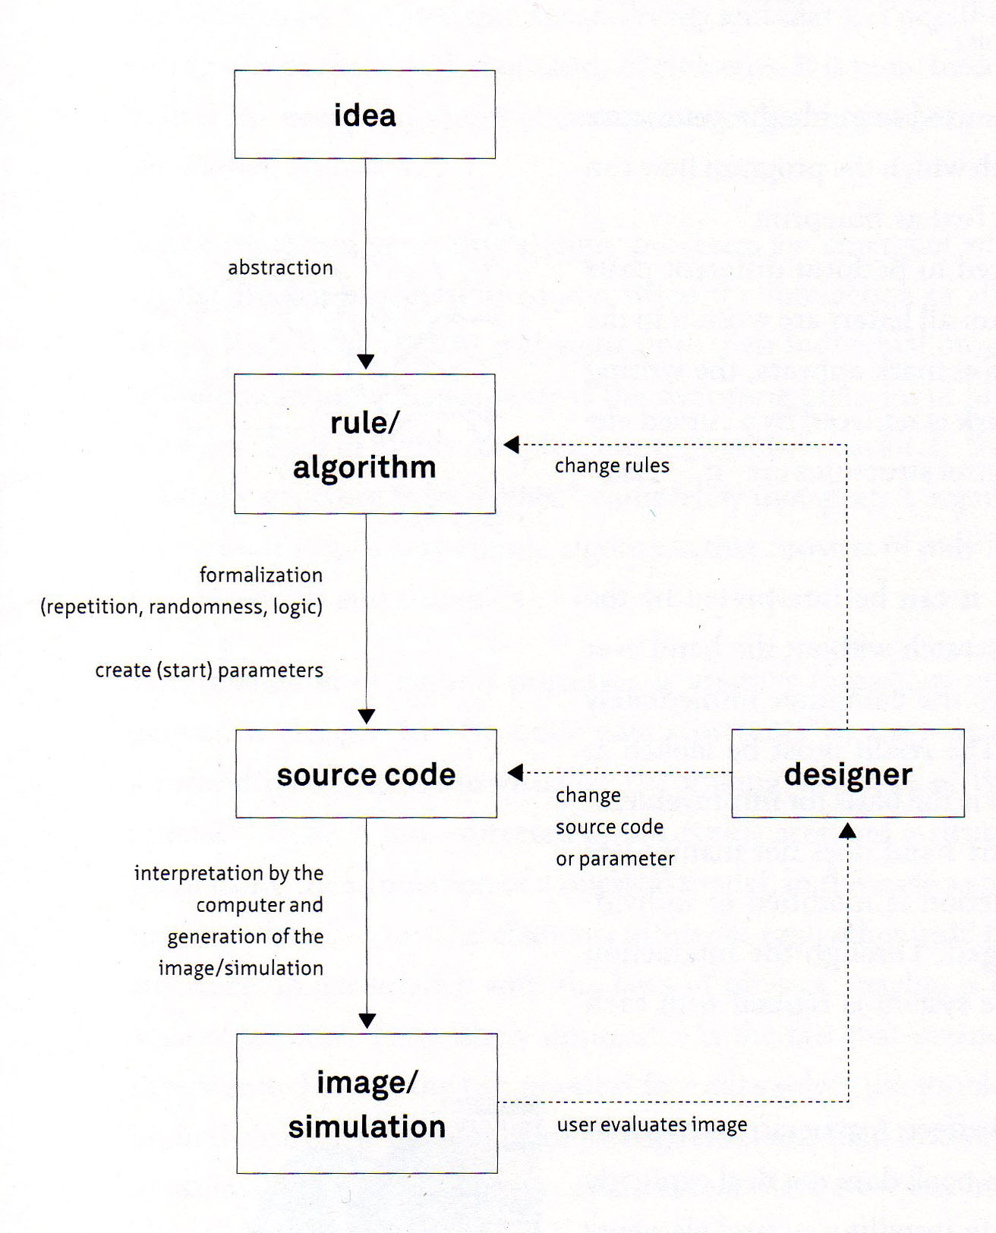
Figure 1: Flowchart of a generative algorithm

Generative design can broadly be defined as the application of algorithms or a "rule-based process through which various potential design solutions can be created" (FASOULAKI, 2008). Generative algorithms are the core engine propelling this design strategy in the computational context. As stated above, all technical drawings in constructions are algorithms of a sort. The variety of buildings designed using these methods is innumerable. Although intended to produce variation, this characteristics is not sufficient to distinguish between generative design techniques and traditional methods. The difference relays in proposing a new the methodology of work.

Generative systems lend a degree of automaticity to the process, hence enabling the user to evaluate a greater number of possible solutions to the architectural problem in a shorter amount of time than would be possible through traditional methods. Could be debated if a CAD command that copies a set of elements along a given curve with equal distances, for example, is a generative algorithm or not. The funicular models used by Gaudi, based on the relation between characteristics of the materials used in the model and the ones used in the actual building (BOADA; ARIBAU,1976), although the lack of a computational application, consists in a better example, hence this models provides way of choosing among possible solutions is identical to the methods investigated by the generative design field.

In Fig. 1 (BOHNACKER; GROSS; LAUB, 2012), a flowchart illustrates, not only the proceedings for creating and operating a generative algorithm, but also the methodological changes involved. The real shift promoted by generative algorithms is in the way of electing the form to be constructed. It starts with an idea of what the constructed object should be, as an abstraction that is translated into a set of rules. An algorithm is implemented in a programming language, code, or a visual programmable ambiance. A simulation of the model is generated by setting parameters values and executing the algorithm. The designer evaluates the output and, by changing the parameters values, the rules, and/or the code, generates different outputs and chooses the final solution among these. The construable artifact appears only when the designer elects the proposal to be built (DINO, 2012).

Many computational methods have been applied for the creation of forms driven by generative algorithms. The shape grammars, proposed by Stiny and Gips in 1971 ( STINY; GIPS, 1972) in the field of art and applied to architecture by Stiny and Mitchell (STINY; MITCHELL, 1978) is considered the first generative design tool. Consisting of four basic elements: a finite set of forms, a finite set of symbols (that represent the set of forms), a finite set of rules (that governs how those forms will be organized in relation with each other) and an initial organization of forms. In each iteration the algorithm rearrange the forms based on the rules. The method is frequently applied to mimic famous architects designs (DUARTE, 2005; TEPAVCEVIC; STOJAKOVIC, 2012). Heuristic optimization algorithms, like genetic algorithms (CALDAS; NORFORD, 1999, 2002; FASOULAKI, 2008), simulated annealing (CERANIC; FRYER; BAINES, 2001; CORREIA; MOTA SOARES, 2001; LAMBERTI, 2008) and tabu search (BLAND; DAWSON, 1991), are largely used to generate architectural forms, particularly to choose between variations of the form that presents better results related to one or more quantitative performances. Swarm intelligence (LUH; LIN; LIN, 2011; YAHYA; SAKA, 2014), are used to simulate the organization and motion in a space and optimize the project based on that information. cellular automata, proposed by Stanislaw Ulam and John von Neumann and systematized by Stephen Wolphram, is a discreet and iterative computational method, represented by a n-dimensional array. The values each element of the array in a given iteration is calculated using the values of the same element and it´s neighbors in the previous iteration, by the application of a defined rule. Algorithms based on cellular automata are also used to generate variety of architectural forms (HERR; KVAN, 2007). The parametric models are among the most used methods of generative algorithms (FISCHER; BURRY; FRAZER, 2005; LACHAUER; JUNGJOHANN; KOTNIK, 2011; MILENA; OGNEN, 2010; TURRIN; VON BUELOW; STOUFFS, 2011) and the characteristics of those algorithms will be discussed in the next section.

Parameter and constraint-based models (PCM)

All generative algorithms, as well as all computer processing, are based on parameters. Parametric design differs from those of others due to its emphasis on the manipulation of parameters (DINO, 2012). To draw a right prism in a CAD system, the user needs to enter values for width, height, and depth. In a parametric design system, each of these inputs can be interactively modified, and the dimensions of the prism are automatically updated in the drawing.

Among the many simulation methods to implement a generative design system, the Constraint Solver, since its introduction by Pro/Engineer in the 1980s, was adopted by most CAD systems (HOFFMANN; JOAN-ARINYO, 2005). It has garnered considerable research interest due to its intuitive and fluid manipulation of forms. The method relies on the satisfaction of constraint problems that, given a finite set of variables, consist of the assignment of these to a finite domain such that the values taken together are restricted by certain constraints, and finding a combination of these values that satisfies all constraints (BARTÁK, 2001). The definition of parameter and constraint-based models proposed here is a way of emphasizing both the parameters and the constraints that define a generative design process.

The creation and manipulation of geometric forms in an ambiance that enables the use of a constraint solver is closely related to proof theory for geometric theorems (HOFFMANN; JOAN-ARINYO, 2005). Geometry has been a cornerstone of architecture and construction throughout history (CECCATO, 2010), and the teaching of generative algorithms should explore geometrical knowledge from an alternative point of view.

Object of study

The Brazilian architect João Filgueiras Lima, better known by his nickname Lelé, is one of the most important and celebrated architects of the country. He is considered by Oscar Niemeyer to be a "great master of architecture," and by Lucio Costa as "the architect in whom art and technology meet and merge" (FERRAZ et al., 2000). His works reveal a strong interest in rational use of materials, an outstanding development of prefabrication, environmental integration and the adoption of innovative daylight and air circulation solutions (CAMPAGNOL, 2014; MACIEL; FORD; LAMBERTS, 2007).

Graduated in architecture from the National School of Fine Arts in 1955, Lelé Joined the construction team of Brasilia in 1957. In that period he developed his technical knowledge on construction and the interest in prefabricated solutions and also have the opportunity to collaborate in many Oscar Niemeyer buildings such as The Justice Ministry, Army Ministry, the National Congress and The vice-president residence (Jaburu’s Palace) among others. The prefabrication experience starts with a temporary residence for the workers, designed in wood, followed by the Taguatinga’s Hospital (1968) and many buildings for the National University Of Brasilia (precast concrete). In this period he also teaches architectural design and coordinate the graduate courses in the same university.

In the 1970’s he was responsible for the urban planning of the state of Bahia Administration Center and some of it’s most iconic Buildings. The Secretariats Buildings (1973), a prefabricated system placed upon a curved prestressed concrete platform casted on site, the Exhibition Center (1974), and the Church of the Bahia Administration Center (1975).

Some very relevant projects where developed and constructed in the 1980’s. The Sarah Kubitschek Hospital of Brasilia (1980) was the first of a network of public medical facilities distributed in some major cities of Brazil that provides free treatment for diseases related to the locomotion apparatus. Most of the furniture and equipments used in the hospitals where also design by Lelé. Highlighting the bed-litter, proposed to serve the patient in all his treatment in the hospitals. The use of the equipment have positively impacted the rates of nosocomial infections in the network. For economy reasons, facing the deficit of public equipment in the country, he proposes factories to produce urban equipment and buildings for some cities administrations (RENURB, 1978; Factory of Abadiana, 1982; Factory in Rio de Janeiro, 1984; FAEC, 1985). A massive number of public schools, nurseries, health clinics, bus stop shelters, prefabricated footbridges (highly integrated with the topography of the city of Salvador), a collaboration with architect Lina Bo Bardi in Salvador old town and other urban equipments where produced in that period.

Starting in the early 1990’s the Sarah Hospital Network begins to expand. From the construction site of the unit in the city of Salvador (1992) another factor raised, able to produce a series of buildings, not only for the network, but also federal and state governments facilities. The increasing adoption of steel structure and folded metal elements from this time resulted in new aesthetic and an increasing complexity of details. The curved shed trusses, for instance, resembles the harmonic and elegant curves that marks the works of Lele’s master, Oscar Niemeyer, translated to steel. The Sarah Hospital of Rio de Janeiro (2008) was the last building produced by that factory.

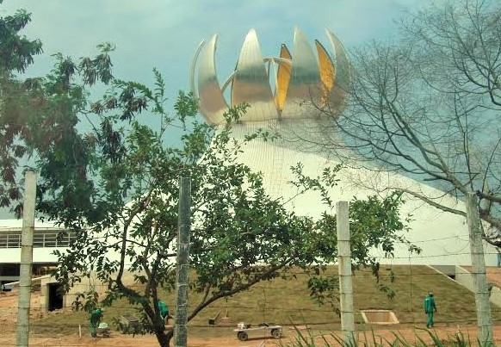
Figure 2: Sarah Kubitschek Hospital auditorium, Rio de Janeiro – RJ. Photo: Liane Flemming

After the Sarah Network experience, Lelé was dedicated to create an NGO called Instituto Habitat, a non-profit organization with focus on project and construction of public buildings, and also an architecture school. Although the institute was never fully operational, projects such as the TRT (the branch of Brazil’s judiciary system that deliberates on labor and work related issues) Head Offices in Salvador, a complex of eight buildings partially inaugurated in 2010, The Darcy Ribeiro Foundation (2010), the Pelourinho/Desterro Footbridge (unbuilt
project, 2014) where developed.

In 2014, the year when his work was celebrated in the Venice Biennial of Architecture, Lelé passed away at the age of 82. His legacy can’t be measured only by the number of projects or the technical complexity of those, the focus of his architecture was always the well-being of the users, the harmony of the space and the economy of resources. A parallel can be traced with the work of Jean Prouvé, as a well established connection between the industry manufacturing technology and architecture, especially if Brazil’s late industrialization is considered.

Examples of the pivoting domes studied in this paper can be found in the auditorium of the Sarah Kubitschek Hospital in Rio de Janeiro (Fig. 2), and also in two buildings of the TRT Head Offices. Figure 3 shows a 3D model of the TRT complex, with the dome of the auditorium (right) and another in the main court building (left).

The first box of the flowchart in Figure 1 represents the idea of the family of forms to be generated. There are didactic advantages in presenting image references to illustrate the idea underlying the generative algorithms to be built. Instead of describing the abstract idea of a goal, the architectural examples clarify important aspects of the intended solution. The application of these elements to real projects, the aesthetic composition that emerged from the varying forms of the domes and their relation with the buildings of which they are part, and the fact that many aspects of the algorithm can be visually identified in the processes, can be mentioned among those advantages.

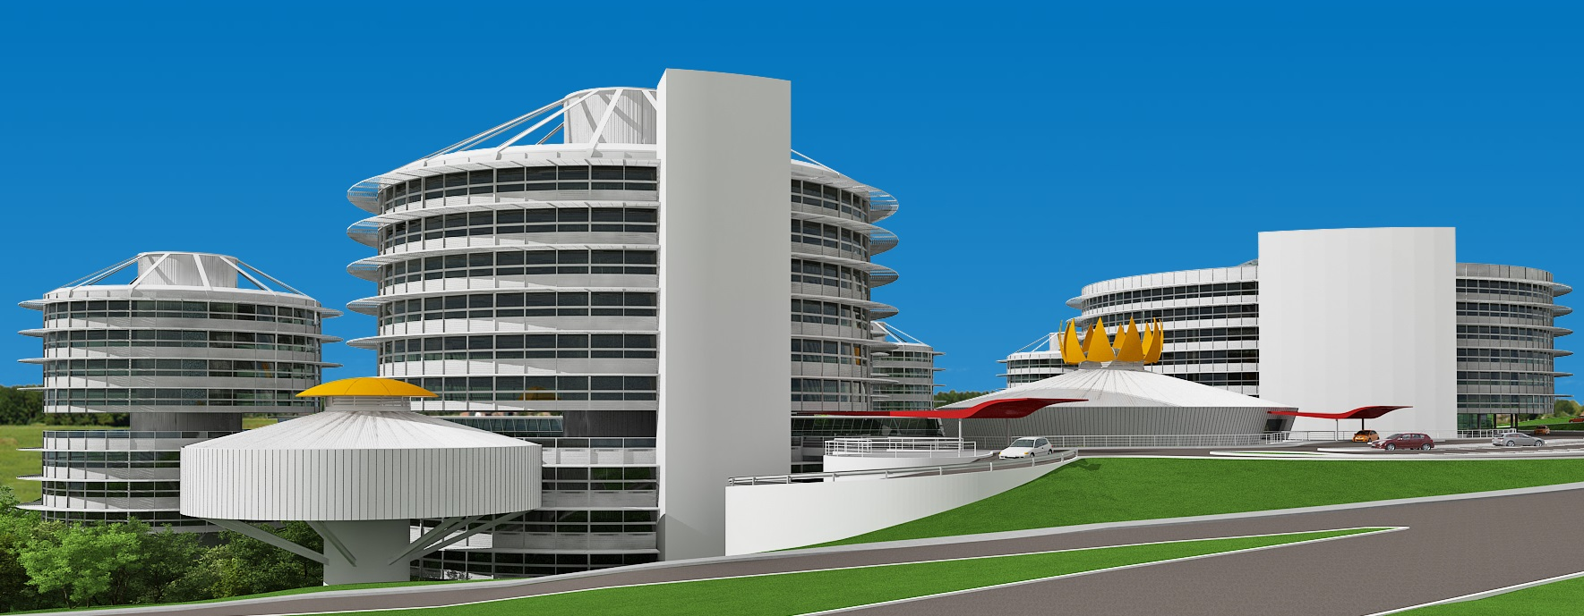
Figure 3: TRT Head Offices, Salvador – Ba. Source: Instituto Habitat archives

Defining the parameters

Starting from the idea, the pivoting domes shown in Figures 2 and 3 should be translated into algorithms that can automatically draw variations of these forms. Analyzing the domes in Figures 2 and 3, the similarities and differences between the chosen solutions can be listed:

- All domes are, when closed, spherical caps.
- There are varying numbers of petals in the examples.
- The base radii and heights of the spherical caps in the examples are different.
- The bases of the petals are at the bases of the spherical caps.
- The tops of the petals are at the maximum height of the sphere.

Based on this visual observations, many elements of the algorithm can be defined. The parameters, for instance, can be the base radius, the center of the base, the maximum height, and the number of petals. Another parameter should be added to the algorithm to simulate the pivoting movement of the dome: a rotation angle parameter.

It is important to note that other parameters can replace the selected ones to draw the same forms. The radius of the full sphere and the differences between the cap height, the center of the sphere, and the sphere radius, for example, can replace the maximum height, the base center, and the cap base radius generating the same geometries. Although equivalent results can be accomplished by the proposed strategies, it is good practice to think about the characteristics of the construction element that are intended to be explored, and how the parameters to be manipulated fit into the process. Let us assume that in the example, the main characteristics to be explored are the area of illumination and ventilation provided by the dome when open, and the aesthetic relationship between the radius and the maximum height. This assumption justifies the proposed parameters, as they directly affect the characteristics under consideration.

Geometric constructions and constraints

In the environment of a geometric constraint solver, the definition of the rules (constraints) can only be conceived by planning the geometric constructions. The first modeling strategy presented in this paper is to model one petal, define a rotation axis (associated with the rotation angle parameter), and copy it around a circle. Figure 4 shows the steps of the algorithm, which are discussed below.
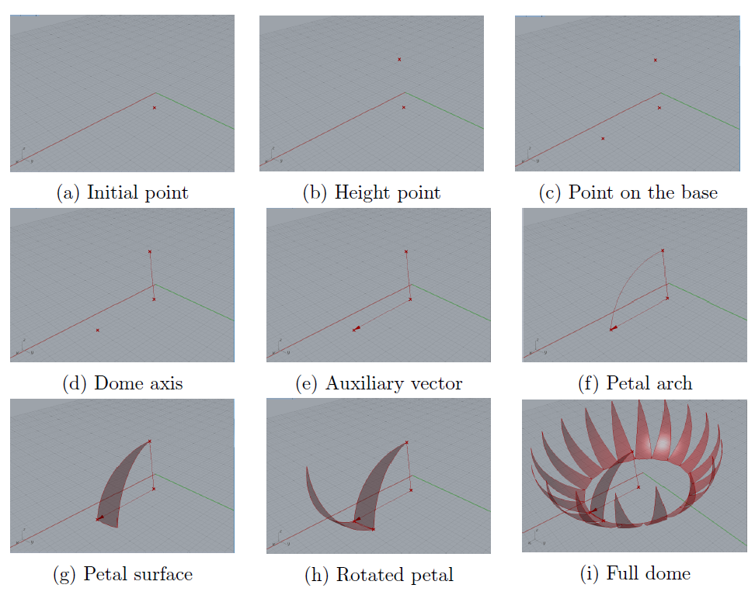
Figure 4: Steps of the one-petal algorithm

Starting from the center (Fig. 4a) of the base circle, we make two copies of the point: one along the z-axis, by the distance entered as the cap height parameter, called the height point (Fig. 4b), and the other along the x-axis, taking the value of the base radius as the module of the translation vector, referred to as a point on the base (Fig. 4c). A line between the base center and the height point is also drawn, and is called the dome axis (Fig. 4d).

The next step is drawing the arc on one side of the petal. As the arcs are drawn independently, the rules that define them should constrain the closed dome as a spherical cap. One of the ways to effectively constrain this construction is to make the arc be tangent, at the height point, to a line or vector parallel to a line drawn from the base center to the point on the base. Figure 5, illustrates this idea by showing that only the blue arcs, which are tangent to the green vectors at the height point, together form a circle arch.

In this step of the algorithm, an opportunity to debate some aspects of the geometric constructions applied should be taken. More precisely, we can reflect on how this arc is defined in classical geometrical drawings, and how this construction is translated into the computational environment.
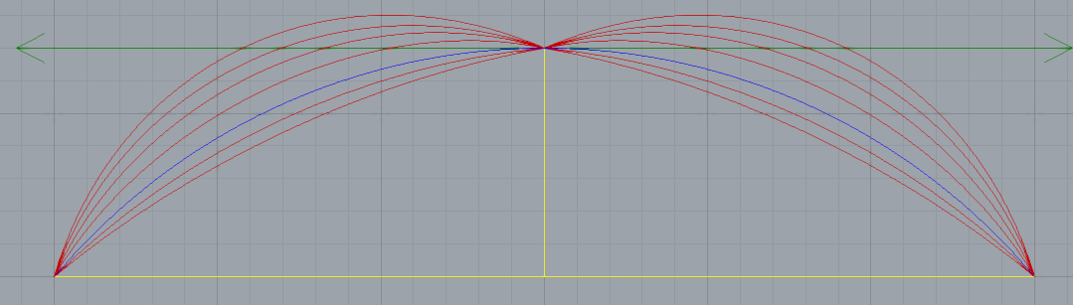
Figure 5: Constraining the arcs as part of a spherical cap

The traditional steps to draw a tangent arc are shown in Figure 6. The construction is based on two properties of circular arcs. One is that the tangent at every point is perpendicular to the radius at the same point. The other is the most basic property of a circle – that every point on it is equidistant to the center.
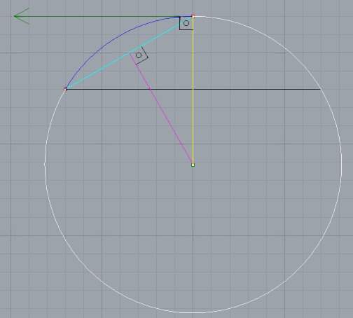
Figure 6: The traditional method to draw a tangent arc
By starting with the two red points and the tangent vector, represented by the green line in Figure 6, and drawing a line perpendicular to the vector at the point where the vector is tangent to the arc, it is safe to say that this perpendicular line (yellow) intersects the center of the sphere. The next step is to find a point on the perpendicular line equidistant to the two points of the arc. This can be done by drawing a segment that connects the two points (cyan), and a perpendicular line through the middle (magenta). The point of intersection of the line perpendicular to the tangent vector and the line drawn through the midpoint of the line connecting the two known points of the arc is equidistant (as are the sides of an isosceles triangle) to these points. Hence, with a compass centered on this intersection, and starting from one of the known points to the other, the arc can be defined (blue).

Is important to note that the white arc in Figure 6 is also tangent to the vector, and contains the two known points. The decision to draw one arc or the other, in the traditional method, is made manually, and relies on an understanding of the intended construction. An arc perpendicular to a line is drawn by considering the orientation of the line but not its sense. In the computational environment, when this method of drawing an arc based on two points and a line is implemented, the sense of the line is used to define the sense in which the arc should be drawn. Figure 7 shows the arcs generated by the method using vectors with opposite senses.

In the proposed algorithm, the reference vector is defined by an ordinate segment from the base center to the point on the base (Fig. 4e). The command that generates an arc from two points and a vector has, as inputs, the height point, the point on the base, and the vector of the tangent to the height point (Fig. 4f). Constructing the arc in this manner constrains the closed dome to a spherical cap, with the height and base radius assuming the values defined by the respective parameters.

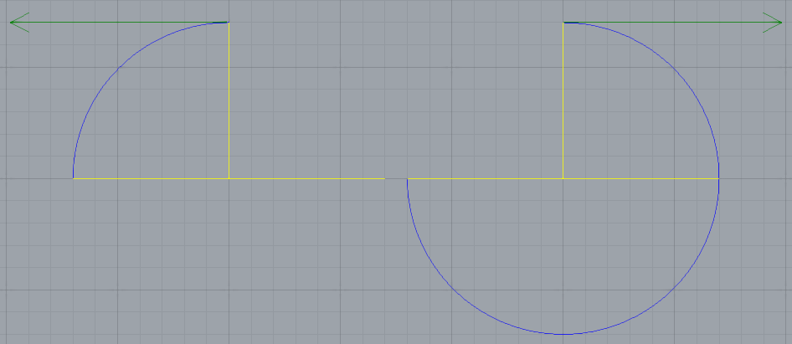
Figure 7: The computational method for drawing the tangent arc

The petal is created as a ruled surface, generated by a rotation around the dome axis in an angle called the petal angle (Fig. 4g). It is obtained by dividing a 360° angel (2 x π in radians) by the number of petals.

To simulate the pivoting movement that opens the dome, a rotation axis connecting the base points of the petal needs to be created. This can be done by rotating the point on the base around the dome axis, taking the petal angle as the extent of rotation. A line is drawn between the two points, and is called the pivot axis.

The petal surface is rotated around the pivot axis by an angle defined by the pivot rotation parameter (Fig. 4h). To complete the algorithm and generate the full dome (Fig. 4i), a polar array of the rotated petals is generated in a 360° angel around the dome axis, taking the number of petals as the number of elements of the array.

The code

Although virtually any programming language can be used to implement the code, the CAD software Rhinoceros 3D (version 5.11) and its plug-in Grasshopper (version 0.9.0076) were chosen due to the intuitive nature of programming through the connection of graphical components, as well as the fact that the forms would hence be created inside a CAD system that can accommodate architectural projects.

Figure 8 shows the code implemented on the programming interface as well as a flowchart of the algorithm. Data flows from left to right through wire-like connections between components.

The grey boxes show the parameters. From top to bottom: height, base center, radius, number of petals, and pivot rotation. The top green box generates the height point, the middle green the point on the base, the bottom green calculates the petal angle. The yellow box on top generates the dome axis by taking the base center and the height point as inputs, and the bottom yellow generates the pivot axis. The auxiliary vector and the petal arch are calculated in the top red box, the middle red box performs the revolutions that generated the petal surface, and the bottom red box rotates it around the pivot axis. The blue box is responsible for the polar array operation that generates the full dome.

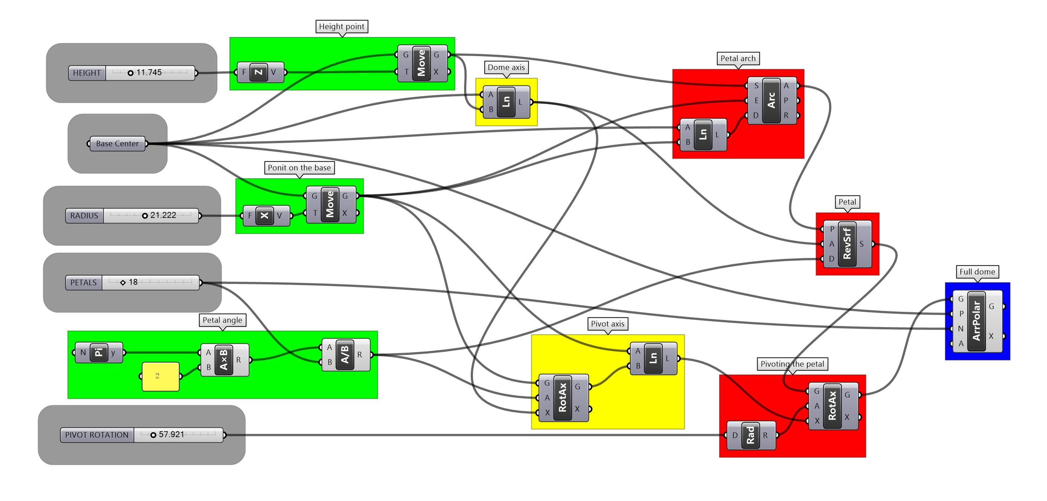
Figure 8: One-petal algorithm

List manipulation-based algorithm

The one-petal algorithm presented in the preceding sections satisfies the conditions and objectives of the proposed generative algorithm. It is an efficient and linear way of defining rules. The list manipulation-based programming strategies are currently related do the LISP programming paradigm proposed by John McCarthy in 1959 (MCCARTHY, 1960). Tightly associated with the artificial intelligence field (STEELE; GABRIEL, 1993), list manipulation also has many applications in CAD environments.

Let us consider, as an example, a line-creation command having as inputs points A and B, that draws a line from start point A to end point B. If the second input is substituted by a list of points B, C, D, and E, the result of this list operation is a list of lines AB, AC, AD, and AE created by the application of a single line command. If two lists are used as input (A, B, C, D, and E, and F, G, H, I, and J) the result will be a list of lines between equivalent points in each ordinate list (AF, BG, CH, DI, and EJ).

A variant of the implementation of the dome algorithm based on list programming is presented in this section to exemplify and introduce the concept. In the one-petal algorithm example, the steps generate one element at a time; in list manipulation-based algorithms, lists of elements are created such that corresponding elements of every petal are drawn simultaneously, and all petals are generated and modified in parallel.

Figure 9 shows the steps of the list manipulation-based strategy. It starts from the base center (Fig. 9a) and creates the height point (Fig. 9b) in the same way as in the previous example. A circle is drawn using the base center and base radius parameters as inputs (Fig. 9c}). The point at the base of the first algorithm is replaced by a base point list (Fig. 9d), all of them restricted to the radial distance from the base center. The dome axis (Fig. 9e) is generated as in the previous rule set. Instead of a single vector, an auxiliary vectors list (Fig.9f) is generated by connecting the base center to the base point list. The petal arcs list (Fig. 9g) is drawn by taking the height point as the start, the base points list as the end, and the auxiliary vectors list as the tangent directions and sense.

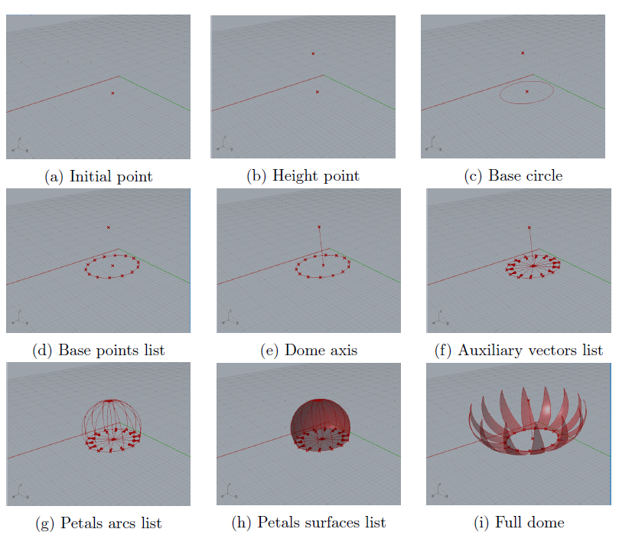
Figure 9: Steps of the list manipulation-based algorithm

Until this point, we have used the ordered lists to execute commands that operate on elements of the lists, and no explicit manipulation has been required. A simple but important operation on the base points list is part of the proposed rules, and is used to generate the forms and exemplify the applications of this programming methodology. The idea is to extract the first element of a list, and append it to the end of the list. In the proposed points list represented as A, B, C, D and E, this operation outputs B, C, D, E and A. Generating lines between equivalent points in the two lists results in a list of lines that connects adjacent points: AB, BC, CD, DE and EA. In Figure 10 this operation is represented in the bottom green box by taking the base points list (middle green box) and generating the shifted points list.

The shifted points list is directly used in the two steps of the algorithm. The first is used to create a pivot axes list by drawing lines between the base points list and the shifted points list (Fig. 10 bottom yellow box). The second is used to generate auxiliary arcs on the petal surface list creation (Fig. 10 bottom red box). The middle green box in Figure 10 generates the base points list by dividing the base circle by the given number of petals. The Grasshopper curve division component also generates a list of the tangent vectors of the curve at the division points. Arcs are drawn with a start point provided by the base points list, end points defined by the correspondent elements in the shifted points list, and with the sense and directions of the equivalent tangent vectors. These auxiliary arcs are used in place of the petal angle in the first algorithm to define the magnitude of the revolution angle of the petal surface (Fig. 10 bottom red box) around the dome axis (Fig. 10 top yellow box). Depending on the programming environment in which the code is implemented, the strategy of using auxiliary arcs or the one that calculates the petal angle, presented in a previous section, could be considered more suitable to generate the petals' surface, but both produce the same results.

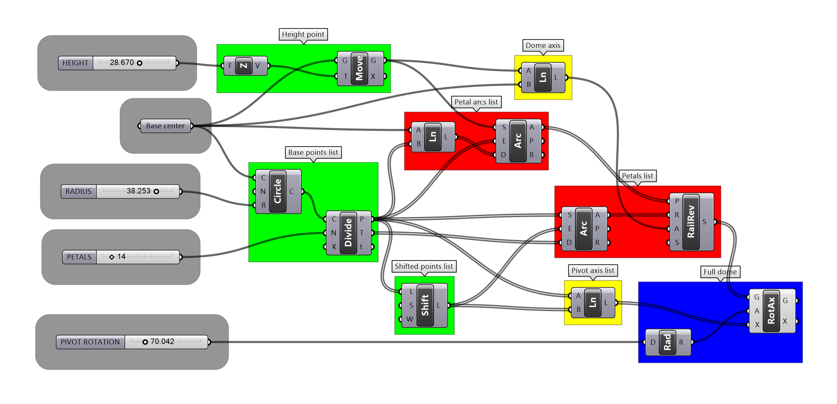
Figure 10: List manipulation-based algorithm

The petal surface list (Fig. 10h) is rotated around the correspondent pivot axes list by the angle provided by the pivot rotation parameter, hence drawing the full dome (Fig. 10i).

Analyzing the algorithm outputs

The flowchart in Figure 1 shows the scenario where, once the idea is established, the rules are planned, the code is implemented, and a form is generated by the first set of parameters, the designer is in charge of evaluating the result, resetting the parameters, and/or modifying the code, and continually repeats this proceedings until a constructive form is selected as the one to be built.

Figure 11 shows a set of solutions generated exclusively by modifications made over the values of the parameters. One of the decisions that the designer should make is the size of the base radius, which is strongly related to the amount of light and the dynamics of the air that should circulate in and out of the building. This evaluation can depend on the designer's experience, and intuition or calculations that can be performed without the aid of computational analysis tools. Since the variations of forms are automatically generated, a tool that analyzes 3D models tends to be more efficient for the task.

Not only the building itself, but the characteristics of the environment should be considered in this choosing process. However, some relations between the parameters result in relevant changes in the generated geometries. In the first row of Figure 11, the domes have larger values for the base radius than for the height parameter; the second line shows equal values, and in the third row, the radius is smaller than the height. This fact can be easily demonstrated geometrically.

The aesthetic impression made by the different simulations can be observed in the images of Figure 11, but is better understood when compared to the domes and respective buildings of Figures 2 and 3. The first one represents a larger value for the height parameter than the radius, producing a fluid relation between the curves of the building's forms and the dome as a finishing element. An inverted configuration of parameters in the relations between these values generates a brusque or even flat interruption of the composition of the forms. In the second figure, the domes adopt a more discrete elevation from the base, in a dialogue with the almost-flat roof solution of the buildings.

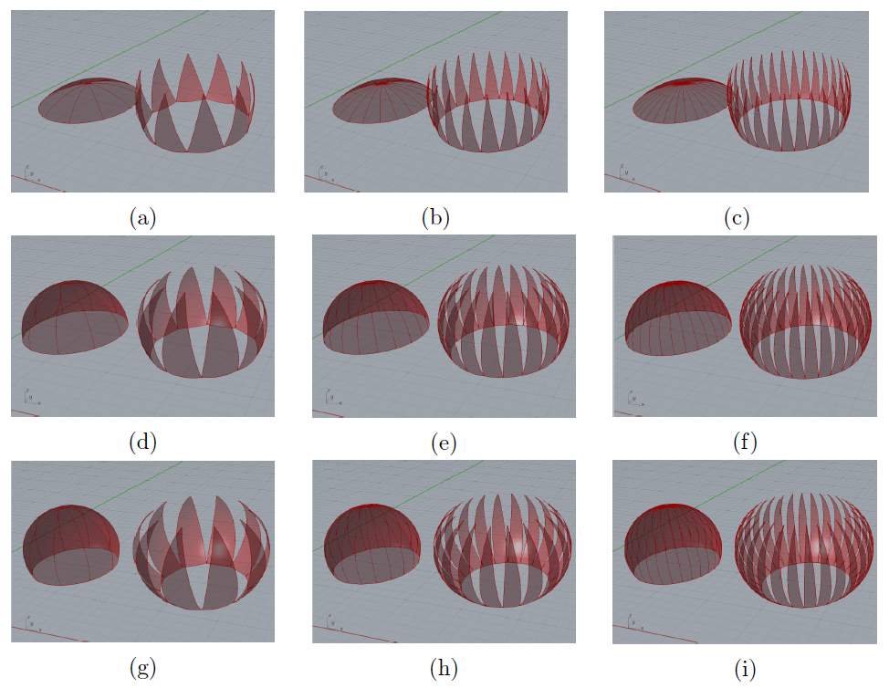
Figure 11: Variant domes created by the algorithms

While the quantitative investigations can be numerically evaluated, the qualitative aspects, as aesthetics, can only be approached and addressed by the raising and answering of some loosely defined questions. The simple analysis proposed here aims to exemplify how these subjective questions can be handled by the methodology of generative algorithms.

Modifying the code

Modification of the parameters is the fastest way to generate alternative results in a generative design system. The results registered in Figure 11 can be generated by both the algorithms presented, but the flowchart in Figure 1 foresees that the code and the rules can also be modified within the scope of the methodology proposed here. To illustrate this, some changes in the list manipulation-based algorithm are proposed to enable the code to create not only spherical cap domes, but also geometries derived from lancet arcs.
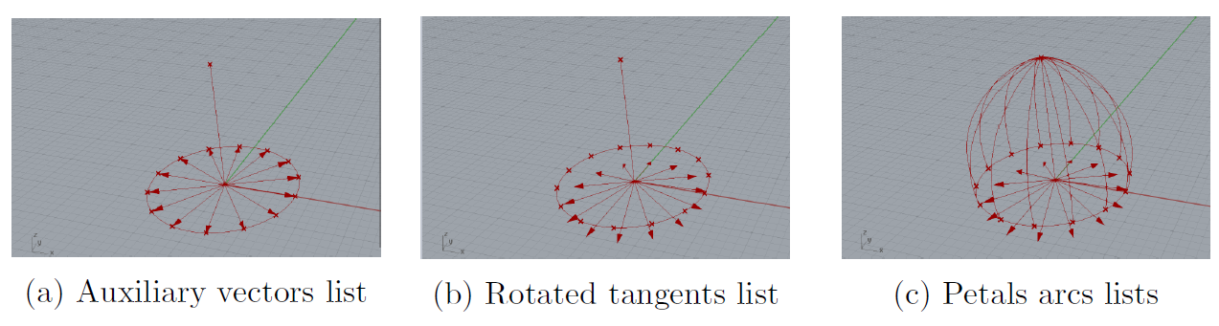
Figure 12: Steps of the lancet dome algorithm

A few modifications are needed to complete this task. The steps presented in Figure 9 are followed in exact order until the auxiliary vectors are created (Fig. 9f). Then, the vectors undergo a rotation defined by a new parameter called tangent rotation (Fig. 12b), and the petals arcs list is created by taking these new vectors as inputs. Following this, the petal surface list and the full dome are created by the same procedures as shown in Figures 9h and 9i.

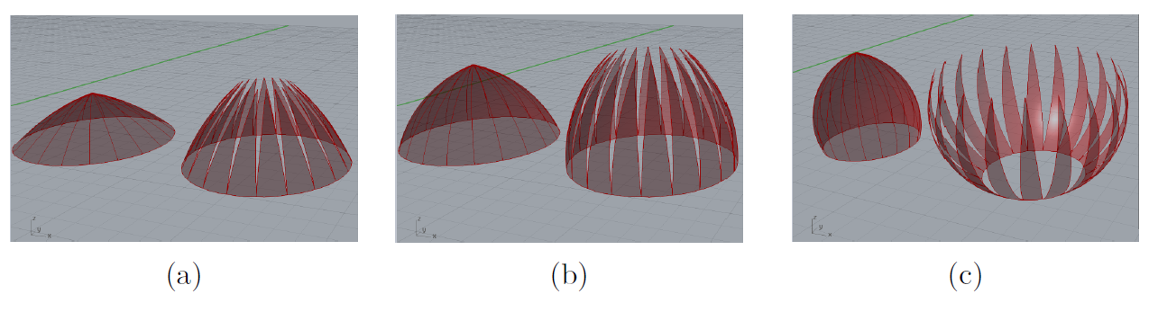
Figure 13: Variant domes created by the lancet arcs algorithm

If the tangent rotation parameter is equal to zero, the results are constrained to geometries similar to the ones presented in Figure 11; otherwise, they assume the pointed end of a lancet arc, as Figure 13 illustrates.

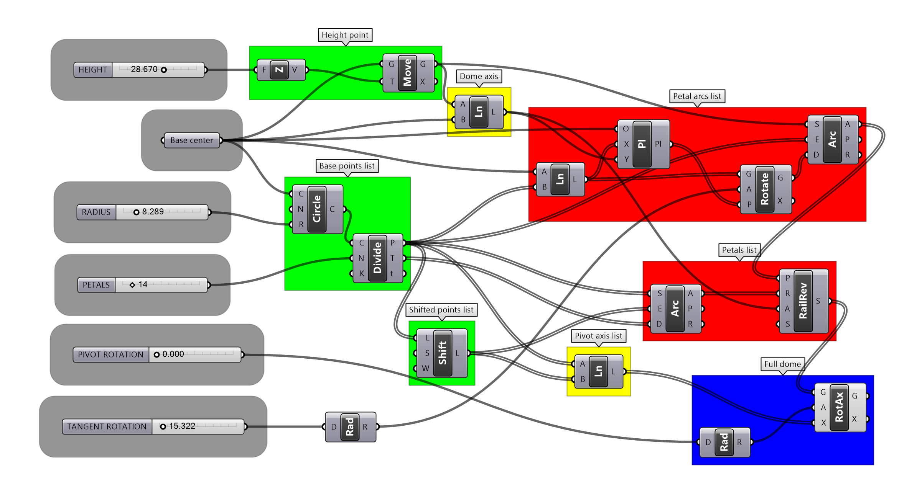
Figure 14: Lancet arc algorithm

The visual code presented in Figure 14 shows these changes in comparison with Figure 10. The tangent rotation parameter is added (bottom grey box), and the auxiliary vectors are rotated around the z-axes of a list of planes created with origin at the base center. The x-axes of each plane in the list is defined by the direction and sense of the corresponding element in the auxiliary vectors list, and the y-axes follows the dome axis oriented line. This rotated tangents list is entered as the vector required by the petal arcs list creation component (top red box).

Conclusion

The proposed exercise discussed in this article succeeded in approaching the basics aspects of the generative design methodology, encompassing all possible variants of the flowchart in Figure 1, explaining the most important geometric constructions used, providing an overview of some programming procedures, and presenting the manner in which constructive forms can be chosen from both qualitative and quantitative aspects.

The implementation of a parameter and constraint-based generative algorithm implicates in a tight combination between two mathematical branches: geometry and logic. Although the one petal algorithm consists in a linear sequence of commands and calculation, the elements of list usage and manipulation became evident when the list manipulation-based algorithm is compared with the first. Facing the difficulties on finding a precise definition for generative algorithms, the example-based strategy also seems to be the most efficient way to clarify it’s meaning.

The quantitative evaluation of air circulation, temperature and the entry of daylight in the buildings where not directly calculated, but the intention to optimize this performances have a strong influence in the conception and manipulation of the algorithm. It´s used to justify the definition of the parameters and to exemplify the evaluation of the outputs.

The overview of Lelé’s career brings context to the experiment. Connects the algorithmic modeling with architectural practice and history. The qualitative evaluation of the outputs is explained in a scenario created not only by the presented images of the buildings but also by the importance of the author and his work to the Brazilian architecture.

A comprehensive understanding of generative design systems demands an interdisciplinary perspective along with the interdisciplinary nature of architecture. The scope of all the different disciplines involved in this exercise was not comprehensively covered by any means, but the effort of bringing these ideas together in a coherent context should guide future works in the area.

References

BARTÁK, R. Theory and Practice of Constraint Propagation In Proceedings of the 3rd Workshop on Constraint Programming in Decision and Control (CPDC 2001). Anais...2001
BENTSCHEFF, I.; GENGNAGEL, C. Towards Teaching Generative Design in Architecture (C. Ceccato, others, Eds.)Advances in Architectural Geometry. Anais...Springer, 2010
BLAND, J. A.; DAWSON, G. P. Tabu search and design optimization. Computer-Aided Design, v. 23, n. 3, p. 195–201, abr. 1991.
PUIG-BOADA, I.; ARIBAU, A. L’eglesia de la colonia Güell. Barcelona: Lumen, 1976.
BOHNACKER, H.; GROSS, B.; LAUB, J. Generative Design: Visualize, Program, and Create with Processing. New York, NY, USA: Princeton Architectural Press, 2012.
CALDAS, L. G.; NORFORD, L. K. A multi-objective genetic algorithm for robust design optimizationACADIA ’99. Anais...Salt Lake City: Acadia’99, 1999
CALDAS, L. G.; NORFORD, L. K. A design optimization tool based on a genetic algorithm. Automation in Construction, v. 11, n. 2, p. 173–184, fev. 2002.
CAMPAGNOL, G. Positive Distraction and the Rehabilitation Hospitals of João Filgueiras Lima. Health Environments Research & Design Journal, v. 8, n. 1, p. 199–227, 2014.
CECCATO, C. The Master-Builder-Geometer (C. Ceccato, L. Hesselgren, M. Pauly, Eds.)Advances in Architectural Geometry 2010. Anais...Springer, 2010
CERANIC, B.; FRYER, C.; BAINES, R. W. An application of simulated annealing to the optimum design of reinforced concrete retaining structures. Computers & Structures, v. 79, n. 17, p. 1569–1581, jul. 2001.
CORREIA, V. M. F.; MOTA SOARES, C. M. C. A. Refined models for the optimal design of adaptive structures using simulated annealing. Composite Structures, v. 54, n. 2-3, p. 161–167, nov. 2001.
DINO, I. G. Creative Design Exploration By Parametric Generative Systems In Architecture. Metu Journal of the Faculty of Architecture, v. 1, p. 207–224, 1 jun. 2012.
DUARTE, J. P. A discursive grammar for customizing mass housing: the case of Siza’s houses at Malagueira. Automation in Construction, v. 14, n. 2, p. 265–275, mar. 2005.
FASOULAKI, E. Integrated Design: A Generative Multi-Performative Design Approach. Cambrige: MIT, 2008.
FERRAZ, M. C. et al. João Filgueiras Lima, Lelé. Lisboa Editorial Blau, 2000.
FISCHER, T.; BURRY, M.; FRAZER, J. Triangulation of generative form for parametric design and rapid prototyping. Automation in Construction, v. 14, n. 2, p. 233–240, mar. 2005.
HERR, C. M.; KVAN, T. Adapting cellular automata to support the architectural design process. Automation in Construction, v. 16, n. 1, p. 61–69, jan. 2007.
HOFFMANN, C. M.; JOAN-ARINYO, R. A brief on constraint solving. Computer-Aided Design and Applications, v. 2, n. 5, p. 655–663, 2005.
KNUTH, D. Fundamental Algorithms. The Art of Computer Programming. 3rd. ed. Massachusetts: Pearson Education, 1997. v. 1
KOLAREVIC, B. (ED). Architecture in the Digital Age: Design and Manufacturing. London: Spon press, 2003.
LACHAUER, L.; JUNGJOHANN, H.; KOTNIK, T. Interactive Parametric Tools for Structural DesignProc IABSE-IASS. Anais...London, UK: 2011
LAMBERTI, L. An efficient simulated annealing algorithm for design optimization of truss structures. Computers & Structures, v. 86, n. 19-20, p. 1936–1953, out. 2008.
LUH, G.-C.; LIN, C.-Y.; LIN, Y.-S. A binary particle swarm optimization for continuum structural topology optimization. Applied Soft Computing, v. 11, n. 2, p. 2833–2844, mar. 2011.
MACIEL, A. A.; FORD, B.; LAMBERTS, R. Main influences on the design philosophy and knowledge basis to bioclimatic integration into architectural design—The example of best practices. Building and Environment, v. 42, n. 10, p. 3762–3773, out. 2007.
MCCARTHY, J. Recursive functions symbolic expressions and their computation by machine, Part I. Communications of the ACM, v. 3, n. 4, p. 184–195, 1960.
MILENA, S.; OGNEN, M. Application of Generative Algorithms in Architectural DesignAdvances in Mathematical and Computational Methods. Anais...2010
MITCHELL, W. J. World’s Greatest Architect MAKING, MEANING, AND NETWORK CULTURE. Cambrige: MIT Press, 2008. v. 40
OXMAN, R. Theory and design in the first digital age. Elsevier, v. 27, n. 3, p. 229–265, maio 2006.
PICON, A. Ornament and its users: from the Vitruvian tradition to the digital age. Le Visiteur, n. 17, p. 176–180, 2011.
STEELE, G. L.; GABRIEL, R. P. The Evolution of Lisp. In: BERGIN JR., T. J.; GIBSON JR., R. G. (Eds.). . ACM SIGPLAN Notices. New York, NY, USA: ACM, 1993. v. 28p. 231–270. STINY, G.; GIPS, J. Shape grammars and the generative specification of painting and sculpture. In: PETROCELLI (Ed.). . Information Processing 71 Proceedings of the IFIP Congress 1971. Volume 2. Auerbach: [s.n.]. v. 71p. 1460–1465.
STINY, G.; MITCHELL, W. J. The Palladian grammar. Environment and Planning B, v. 5, n. 1, p. 5–18, 1978.
TEPAVCEVIC, B.; STOJAKOVIC, V. Shape grammar in contemporary architectural theory and design. Facta universitatis - series: Architecture and Civil Engineering, v. 10, n. 2, p. 169–178, 2012.
TERZIDIS, K. Algorithmic architecture. [s.l.] Taylor \& Francis, 2006. v. 1
TURRIN, M.; VON BUELOW, P.; STOUFFS, R. Design explorations of performance driven geometry in architectural design using parametric modeling and genetic algorithms. Advanced Engineering Informatics, v. 25, n. 4, p. 656–675, out. 2011.
YAHYA, M.; SAKA, M. P. Construction site layout planning using multi-objective artificial bee colony algorithm with Levy flights. Automation in Construction, v. 38, p. 14–29, mar. 2014.

